**White Box Testing**

**Team Member: Don Valino = X00112730**

**Gareth Quirke = X0**

**Graham Timmins = X00103868**

**Program: trafficfine_v2**

public class trafficfine_v2

{

public static void main(String[] args) {

1 String fine = new String();

2 int speed, limit;

3 try {

4 speed = Integer.parseInt(args[0]);

5 limit = Integer.parseInt(args[1]);

6 if (limit == 30) {

7 if (speed > 100) {

8 fine = "SUSPEND";

9 } else if (speed > 50 && speed <= 100) {

10 fine = "EUR 100";

11 } else if (speed > 30 && speed <= 50) {

12 fine = "EUR 80";

13 } else {

14 fine = "EUR 0";

}

15 } else if (limit == 50) {

16 if (speed > 120) {

17 fine = "SUSPEND";

18 } else if (speed > 80 && speed <= 120) {

19 fine = "EUR 150";

20 } else if (speed > 50 && speed <= 80) {

21 fine = "EUR 100";

22 } else {

23 fine = "EUR 0";

}

24 } else if (limit == 120) {

25 if (speed > 200) {

26 fine = "SUSPEND";

27 } else if (speed > 120) {

28 fine = "EUR 250";

29 } else {

30 fine = "EUR 0";

}

31 } else

32 fine = "Invalid limit specified";

33 } catch (Exception e) {

34 fine = "Invalid input";

}

35 System.out.println(fine);

}

}

Program Flow Graph

Produced by: Don Valino, Graham Timmins & Gareth Quirke

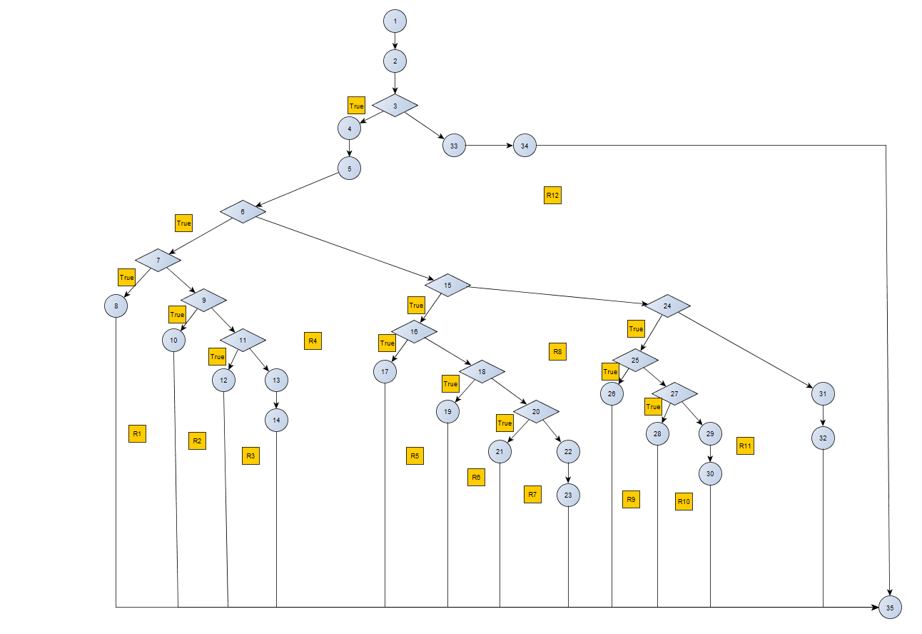

Calculating CC

CC(G) = Number(Edge) – Number(Nodes) + 2(no. of exit points) = 46 – 35 + 2 = 13

CC(G) = Number of Nodes with a condition + 1 = 12 + 1 = 13

CC(G) = Number of Region + 1 = 13

Set of basis paths through the code Produced by: **Don Valino, Graham Timmins & Gareth Quirke**

1,2,3,4,5,6,7,8,35

1,2,3,4,5,6,7,9,10,35

1,2,3,4,5,6,7,9,11,12,35

1,2,3,4,5,6,7,9,11,13,14,35

1,2,3,4,5,6,15,16,17,35

1,2,3,4,5,6,15,16,18,19,35

1,2,3,4,5,6,15,16,18,20,21,35

1,2,3,4,5,6,15,16,18,20,22,23,35

1,2,3,4,5,6,15,24,25,26,35

1,2,3,4,5,6,15,24,25,27,28,35

1,2,3,4,5,6,15,24,25,27,29,30,35

1,2,3,4,5,6,15,24,31,32,35

1,2,3,33,34,35

Test Cases for each Path

#Test Case for 1,2,3,4,5,6,7,8,35

#Written by: Graham Timmins

#Input: speed = 101 speed limit = 30

#Expected Output: SUSPEND

#Output =

java trafficfine_v2 101 30

#We are expecting the program trafficfine_v2 to be already compiled

#Test Case for 1,2,3,4,5,6,7,9,10,35

#Written by: Don Valino

#Input: speed = 61 speed limit: 30

#Expected Output: EUR 100

#Output =

java trafficfine_v2 61 30

#We are expecting the program trafficfine_v2 to be already compiled

#Test case for 1,2,3,4,5,6,7,9,11,12,35

#Written by: Don Valino

#Input: speed = 35 speed limit = 30

#Expected output: EUR 80

#output =

java trafficfine_v2 35 30

#We are expecting the program trafficfine_v2 to be already compiled

#Test case for 1,2,3,4,5,6,7,11,13,14,35

#Written by: Gareth Quirke

#Input: speed = 28 , speed limit: 30

#Expected output: EUR 0

#output = EUR 0

java trafficfine_v2 28 30

#We are expecting the program trafficfine_v2 to be already compiled

#Test case for 1,2,3,4,5,6,15,16,17,35

#Written by: Graham Timmins

#Input: speed = 121 , speed limit: 50

#Expected output: SUSPEND

#output =

java trafficfine_v2 121 50

#We are expecting the program trafficfine_v2 to be already compiled

#Test case for 1,2,3,4,5,6,15,16,18,19,35

#Written by: Gareth Quirke

#Input: speed = 90 , speed limit: 50

#Expected output: EUR 150

#output =

java trafficfine_v2 90 50

#We are expecting the program trafficfine_v2 to be already compiled

#Test case for 1,2,3,4,5,6,15,16,18,20,21,35

#Written by: Don Valino

#Input: speed = 61 , speed limit: 50

#Expected output: EUR 100

#output =

java trafficfine_v2 61 50

#We are expecting the program trafficfine_v2 to be already compiled

#Test case for 1,2,3,4,5,6,15,16,18,20,22,23,35

#Written by: Gareth Quirke

#Input: speed = 49 , speed limit: 50

#Expected output: EUR 0

#output =

java trafficfine_v2 49 50

#We are expecting the program trafficfine_v2 to be already compiled

#Test case for 1,2,3,33,34,35

#Written by: Graham Timmins

#Input: speed = e , speed limit: e

#Expected output: Invalid input

#output =

java trafficfine_v2 e e

#We are expecting the program trafficfine_v2 to be already compiled

#Test case for 1,2,3,4,5,6,15,24,31,32,35

#Written by: Gareth Quirke

#Input: speed = 20 , speed limit: 140

#Expected output: Invalid limit specified

#output =

java trafficfine_v2 20 140

#We are expecting the program trafficfine_v2 to be already compiled

#Test case for 1,2,3,4,5,6,15,24,25,26,35

#Written by: Don Valino

#Input: speed = 202 , speed limit: 120

#Expected output: SUSPEND

#output =

java trafficfine_v2 202 120

#We are expecting the program trafficfine_v2 to be already compiled

#Test case for 1,2,3,4,5,6,15,24,25,27,28,35

#Written by: Gareth Quirke

#Input: speed = 121 , speed limit: 120

#Expected output: EUR 250

#output =

java trafficfine_v2 121 120

#We are expecting the program trafficfine_v2 to be already compiled

#Test case for 1,2,3,4,5,6,15,24,25,27,29,30,35

#Written by: Don Valino

#Input: speed = 119 , speed limit: 120

#Expected output: EUR 0

#output =

java trafficfine_v2 119 120

#We are expecting the program trafficfine_v2 to be already compiled